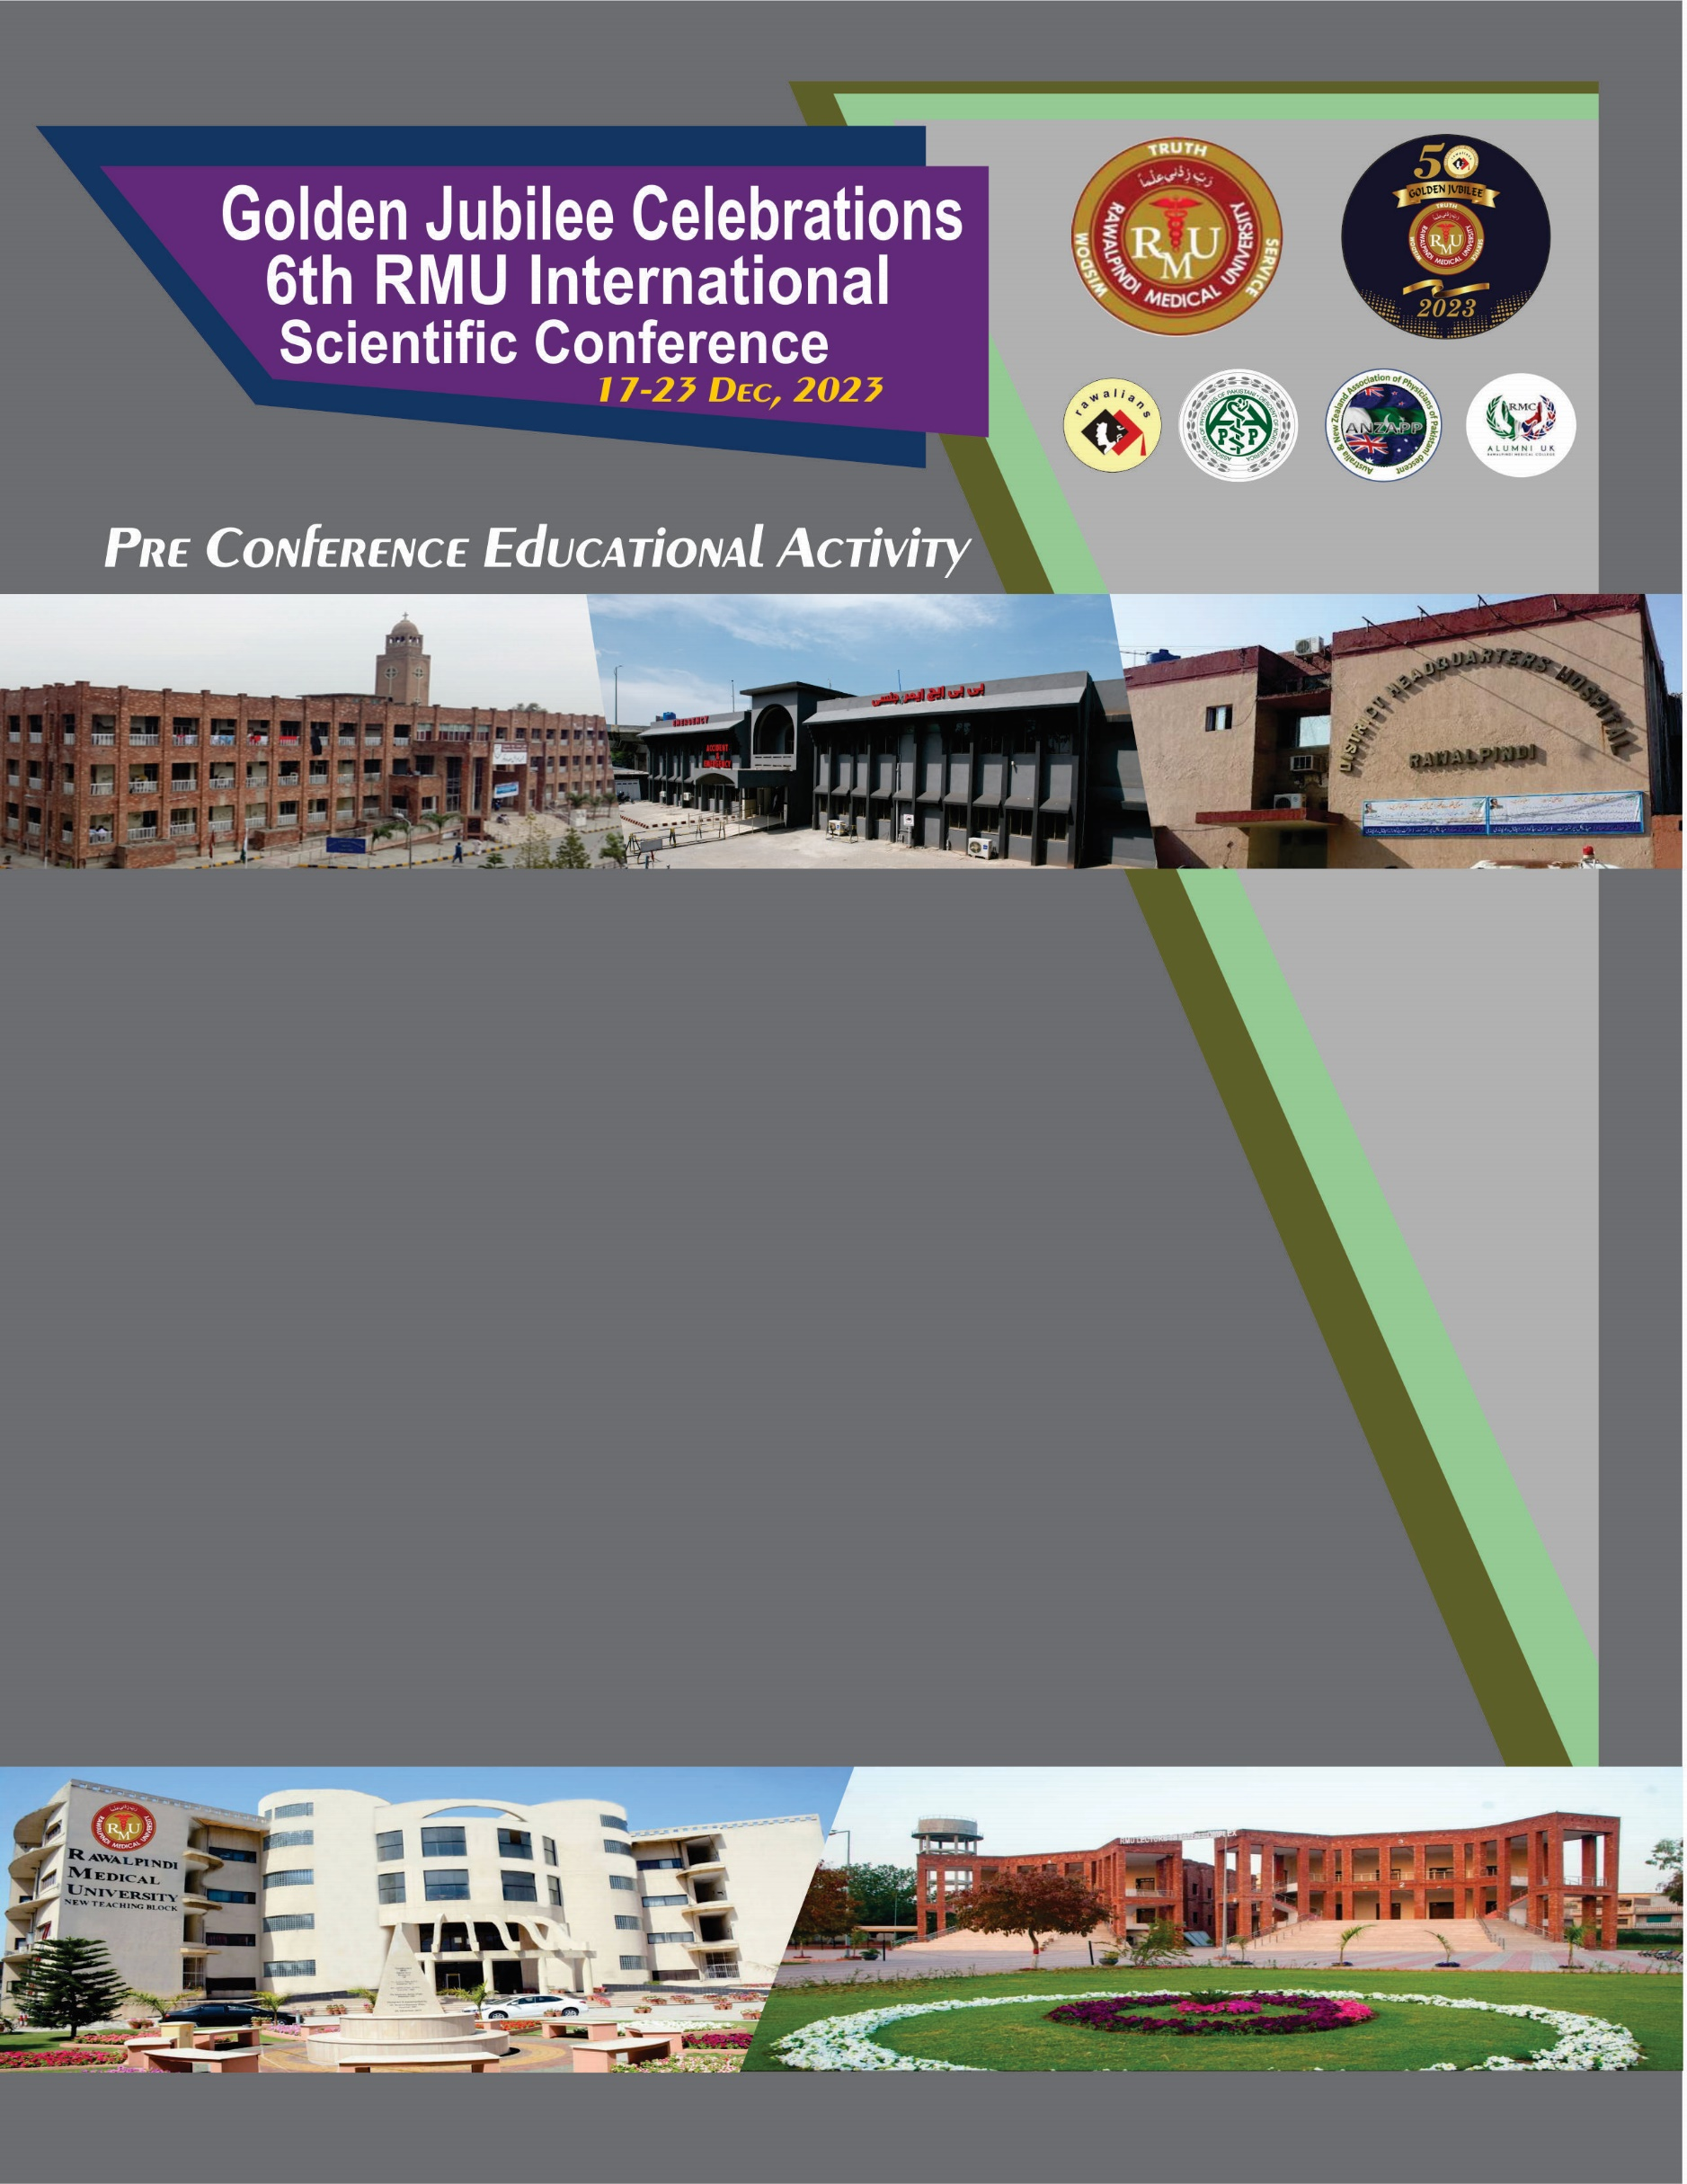

**Title of the Activity**

**Type of Activity: Workshop/ Master Class/ Symposia / Meet the Experts Session (you can choice any one )**

**(Note: This poster template is editable you can chose content accordingly )**

**Date Time**

**Organized by**



COORDINATOR

COURSE DIRECTOR

CO DIRECTOR

FACILITATOR

**Number of Organizers can be increased accordingly**

**Venue:**